Project Overview The Student Information System is built to manage student records. The goal of this project was to practice Java basics, including variable instantiation, object-oriented concepts (Classes, Encapsulation), Scanner utilization for inputs, and ArrayList manipulation.
Setup Instructions Requires Java 11 or higher.
- Download the source files into a folder named src.
- Open a terminal in the folder.
- Run javac *.java to compile.
- Run java StudentInformationSystem to start the app.
Code Structure The application implements separation of concerns:
- Student.java: The model class storing properties (id, name, age, grade, contact) and getters/setters.
- ValidationUtils.java: A utility class housing methods to validate inputs (checking if age > 0 and grade ranges).
- StudentManager.java: Handles business logic. Manages the ArrayList<Student> and provides CRUD functionality.
- StudentInformationSystem.java: The entry point. Handles the Scanner UI and user menus.
Visual Documentation
Adding Student Details
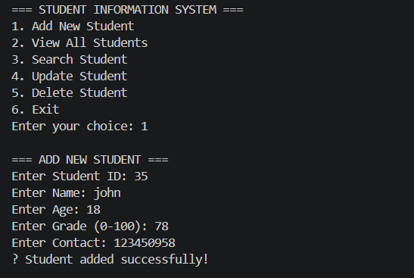

View Details
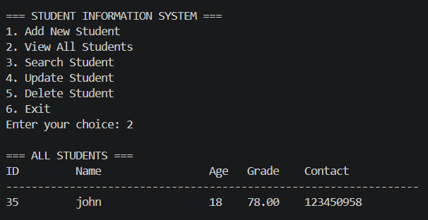
Update Details
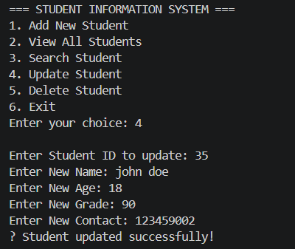
Technical Details
- Data Structures: The project relies on an ArrayList<Student> to persist data during runtime because it allows for dynamic resizing, unlike standard arrays.
- Error Handling: Basic try-catch blocks are used when parsing integer/double inputs to prevent the InputMismatchException from crashing the application if a user types letters instead of numbers.

Testing Evidence
- Test Case 1 (Validation): Attempted to add a student with age -5. System successfully blocked the entry and displayed an error.
- Test Case 2 (Search): Added user "John Doe" with ID "S01". Searched "S01", and system correctly pulled the data. Searched for a non-existent ID, system returned "Student not found."

